Download putty

[**https://www.putty.org/**](https://www.putty.org/)

**19.**  **Download Puttygen from** [**https://www.puttygen.com/**](https://www.puttygen.com/)

**20.**  **Click “load” in Putty Key Generator. Select the .pem file from your system downloaded in step 17**

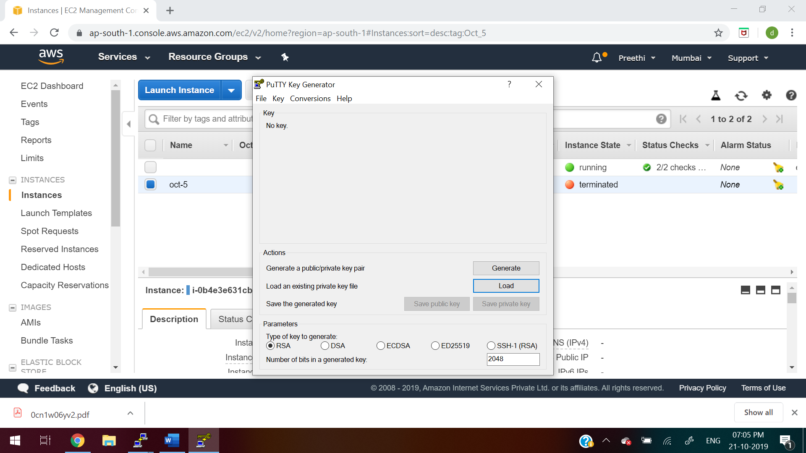

**21. After that, follow the below steps:**

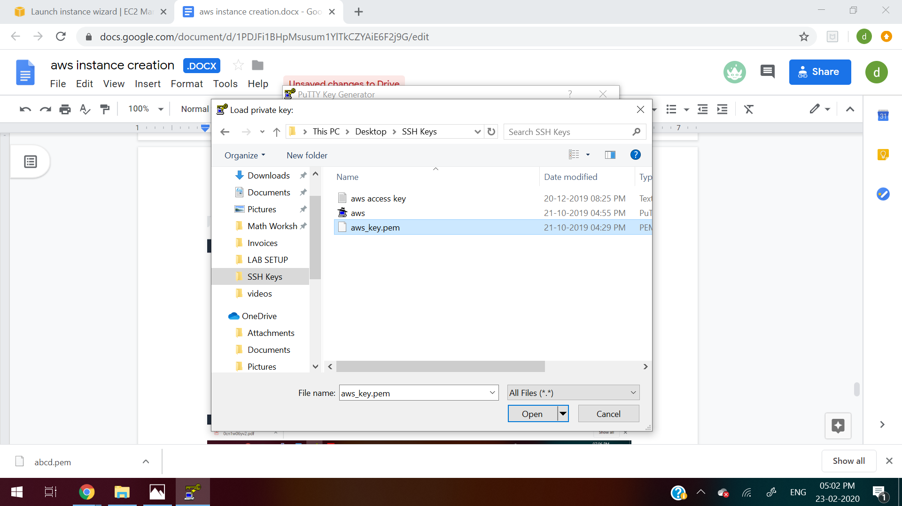

**22. click on “Save private key”. Give name as aws.ppk file**

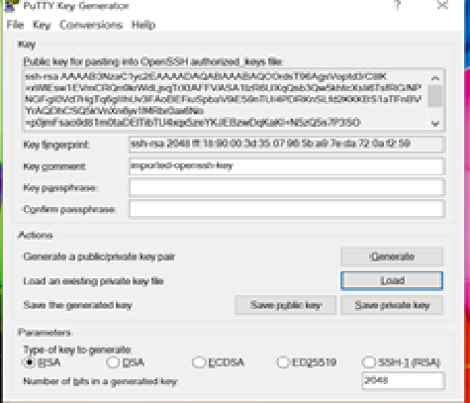

**23. Go to Putty. In the host name, give Public Dns or Public IP**

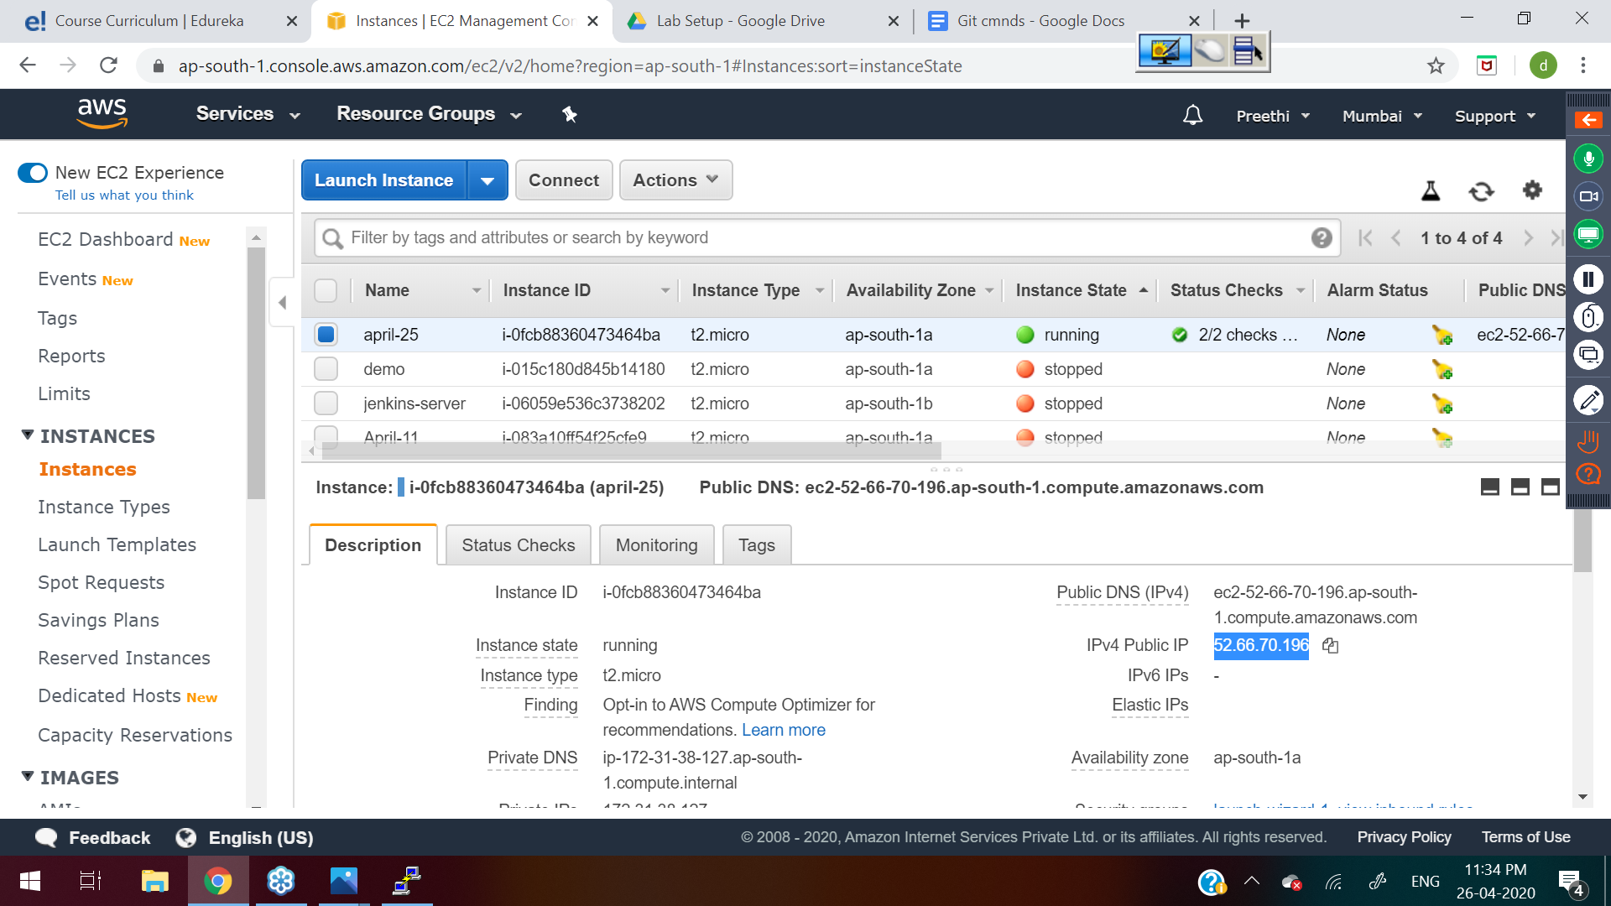

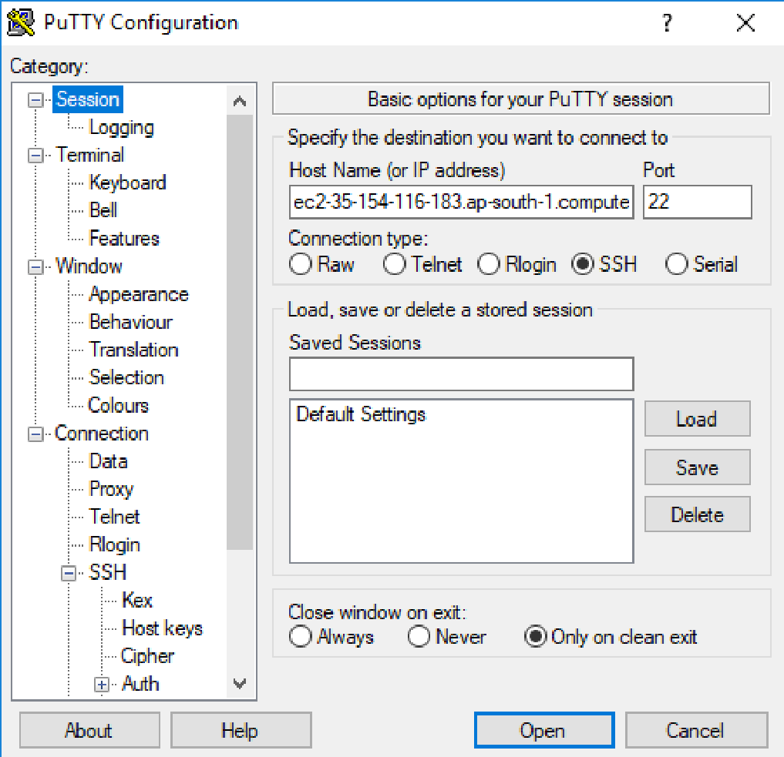

**24. Now go to ssh->auth and browse the aws.ppk file generated in step 22**

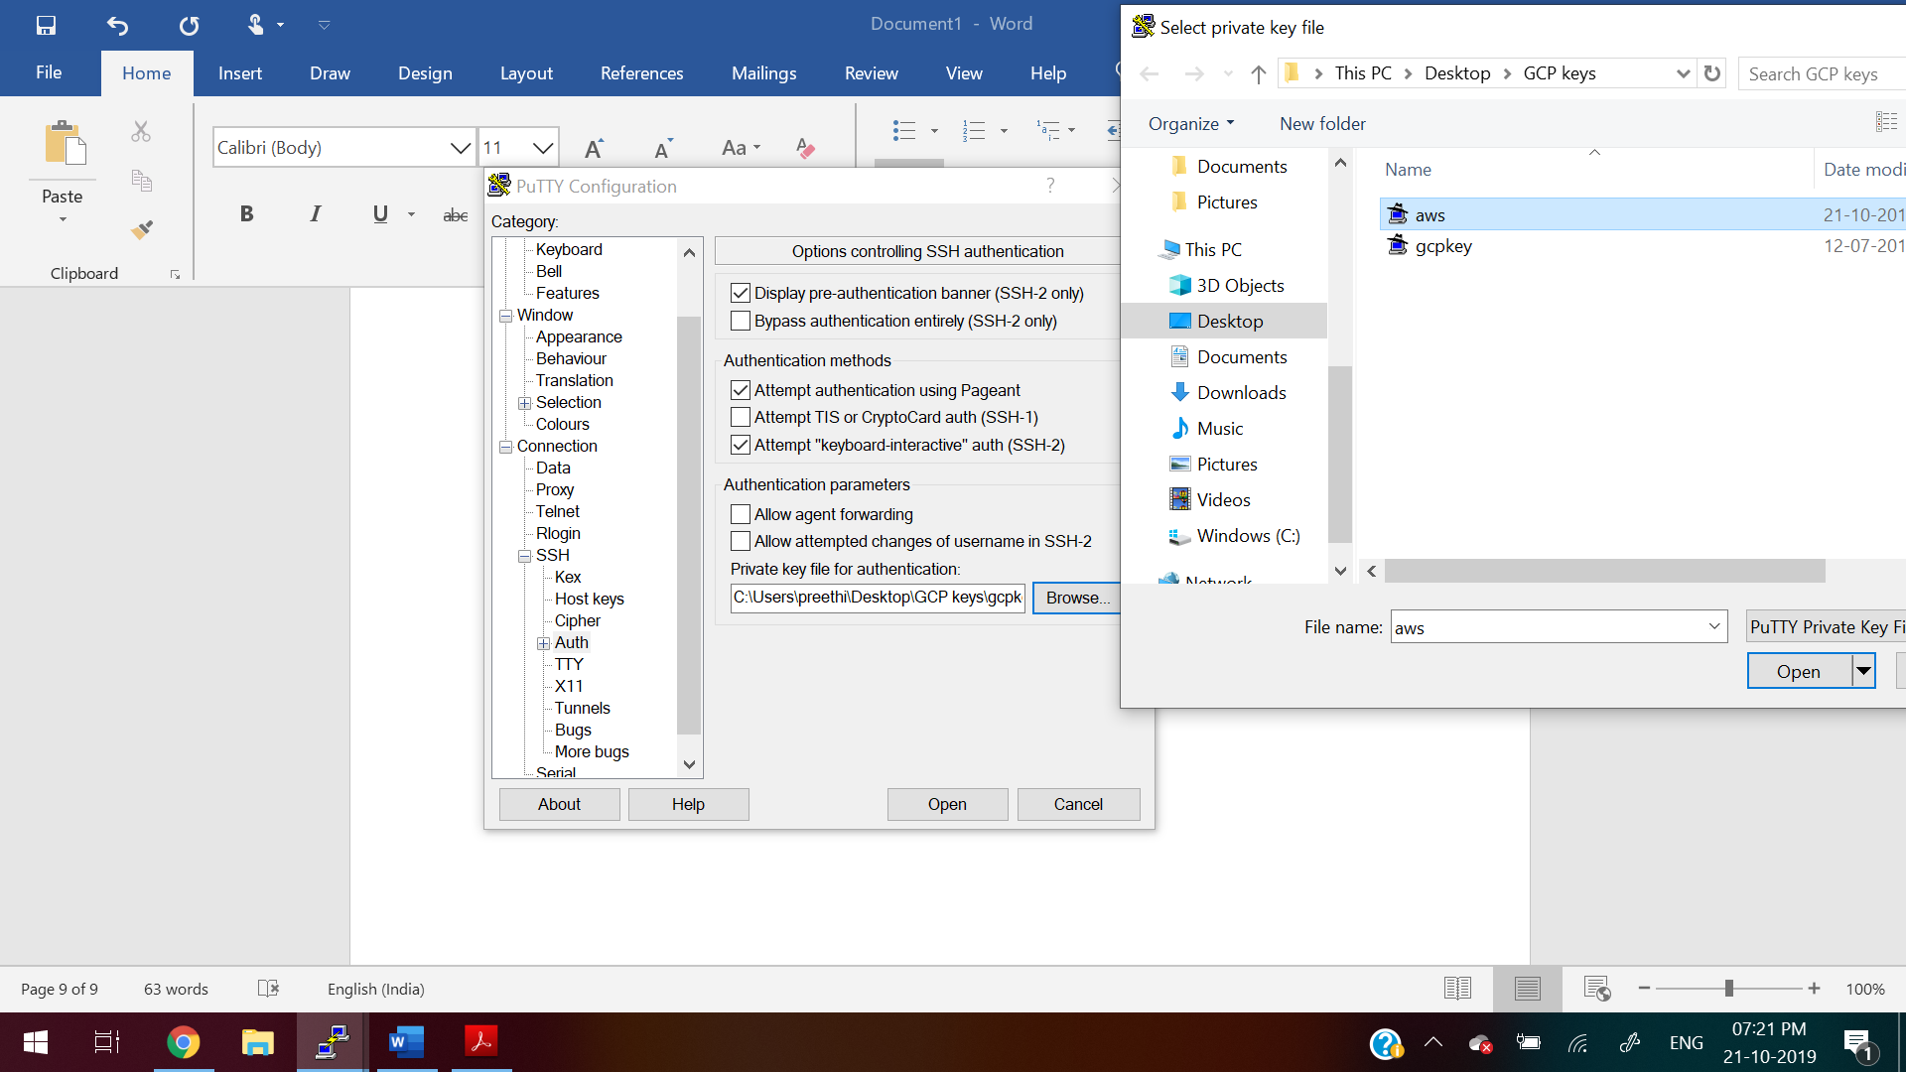

**25.Give the username as “ec2-user” login**

**Then to switch as root user**

**sudo su -**

**For Reference:**

[**https://linuxacademy.com/guide/17385-use-putty-to-access-ec2-linux-instances-via-ssh-from-windows/**](https://linuxacademy.com/guide/17385-use-putty-to-access-ec2-linux-instances-via-ssh-from-windows/)

[**https://docs.aws.amazon.com/AWSEC2/latest/UserGuide/putty.html**](https://docs.aws.amazon.com/AWSEC2/latest/UserGuide/putty.html)